**HAND GESTURE CONTROLLED BED FOR PHYSICALLY CHALLENGED PEOPLE**

**AIM OF THE MODEL:**

To design a patient care bed system for physically challenged with automated bed positioning (up, down, left, right) using hand gestures and early detection of patient fall.

**BLOCK DIAGRAM AND FUNCTION DESCRIPTION:**

A particular gesture input is given by the patient to the system, then this gesture is given to the Raspberrypi micro-processor via USB webcam. The micro-processor further processes the input image using image processing techniques to segment the hand portion and extract the gestures based on angles, positions and contours of the fingers as shown in Fig.1. Based on the gestures, signals are generated which is used to changes the position of the bed (up, down, left, right) automatically with the help of stepper motor as shown in Fig.2 and the accelerometer is used for early detection of patient fall.

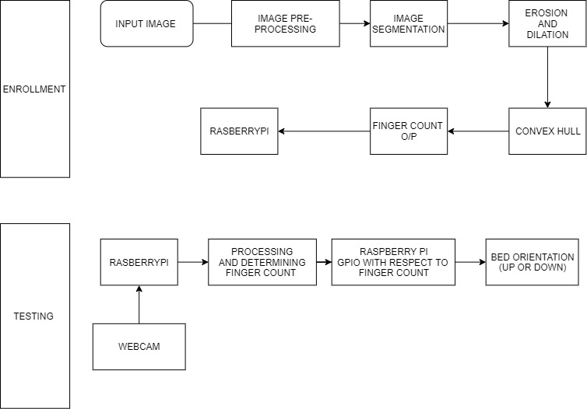

**Fig.1 Block diagram of proposed model**

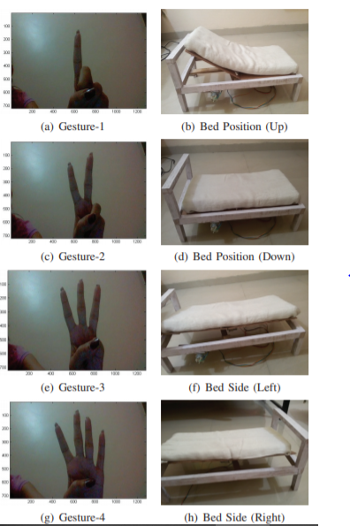

**Fig. 2 Bed positions based on hand gestures**

**MATERIALS AND EQUIPMENTS REQUIRED:**

1. **RASPBERRYPI 4:**

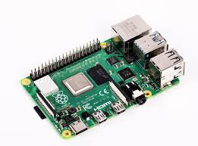

**2.WEBCAM:**

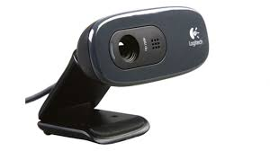

1. **STEPPER MOTOR:**

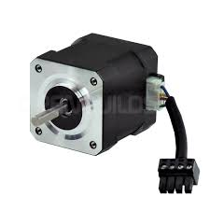

## ACCELEROMETER:

## 

**ESTIMATED COST:**

|  |  |  |
| --- | --- | --- |
| **S.NO** | **COMPONENTS** | **COST (INR)** |
| **1.** | **RASPBERRYPI 4** | **9000** |
| **2.** | **WEBCAM** | **3000** |
| **3.** | **STEPPER MOTOR** | **9000** |
| **4.** | **ACCELEROMETER AND SOFTWARE** | **4000** |
| **5.** | **BED DESIGN**  **(hydrolic bed design based on sensors)** | **100000** |
|  | **TOTAL:** | **125000** |